**Advanced Software Engineering**

**Lab Assignment 2**

**Ravi Teja Soma**

**Class Id: 85**

Wireframes and a web application with at least 3 pages were created:

In **Login page** I created 2 buttons login, register.

• On clicking register button, register page is opened

• On clicking login, home page is opened.

In **Register Page** basic information of the user is taken.

In **Home page** I used external web service to mark Departure and Arrival using Google Map Web

The weather of the departure and destination can be brought using the vie weather function.

Code Quality is checked using the jslint

: Check the quality of your code using

JavaScript Code Quality Tool

JSLint

http://www.jslint.com

**Registration Page:**

The user can register on this page.

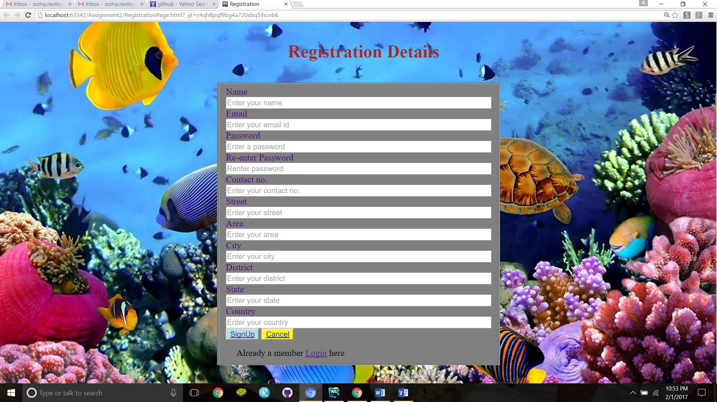

**Registration Success Page:**



**Login Page:**

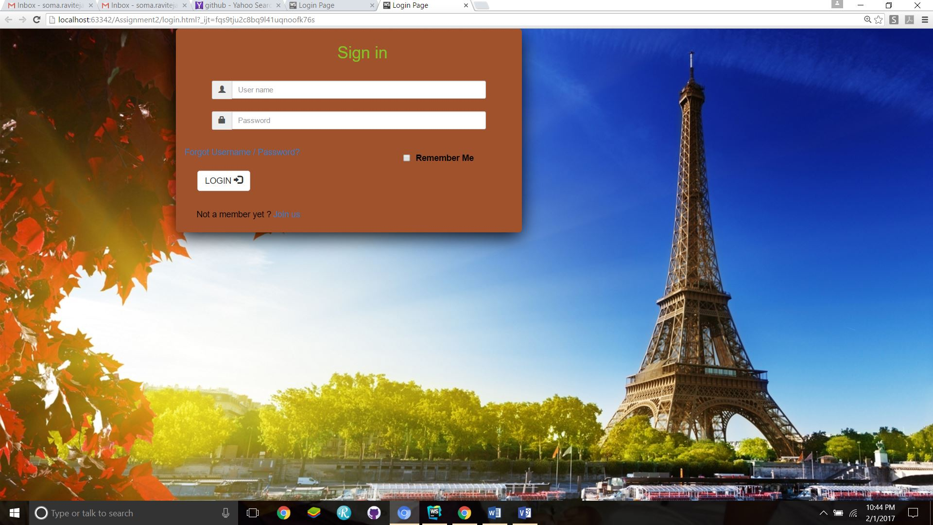

**Home Page:**

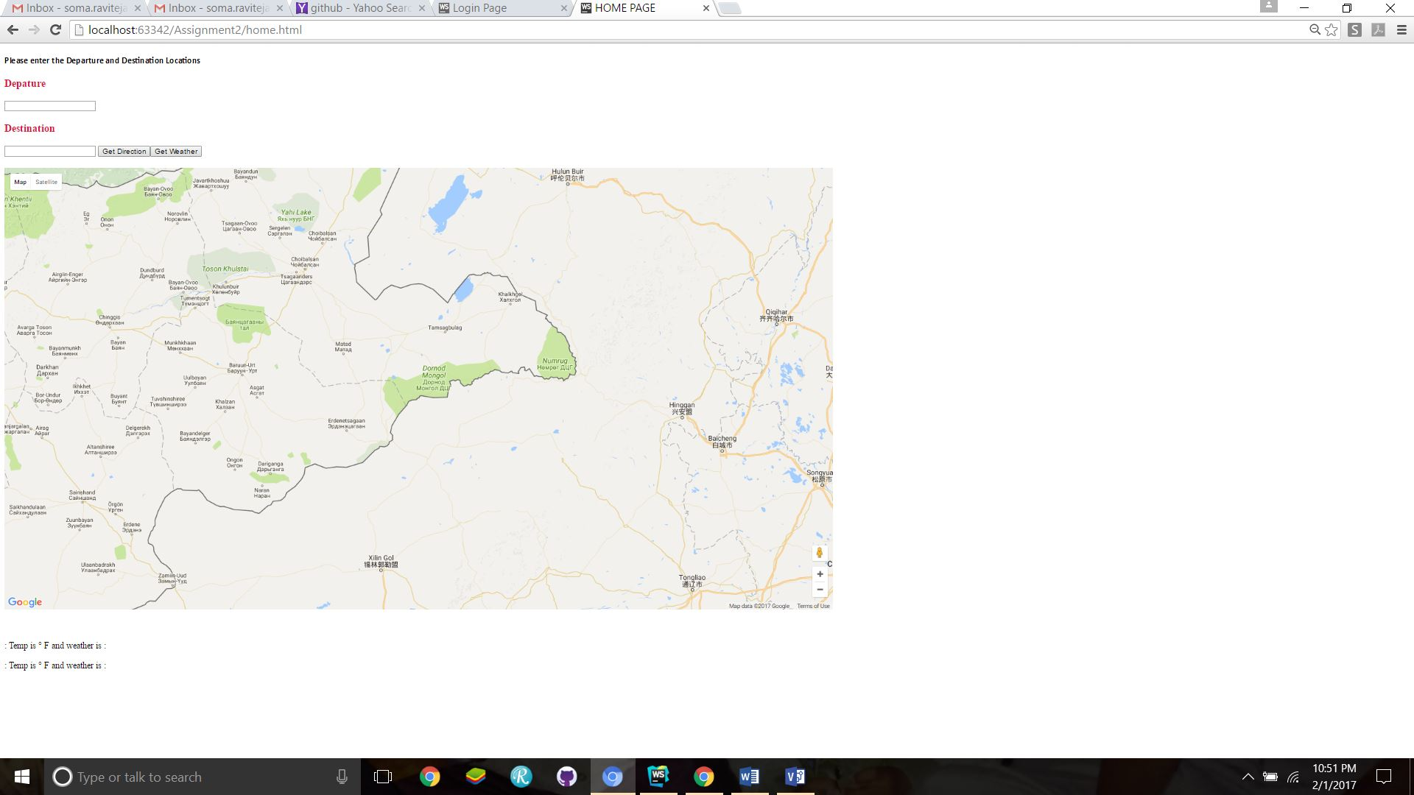

**Directions Page:**

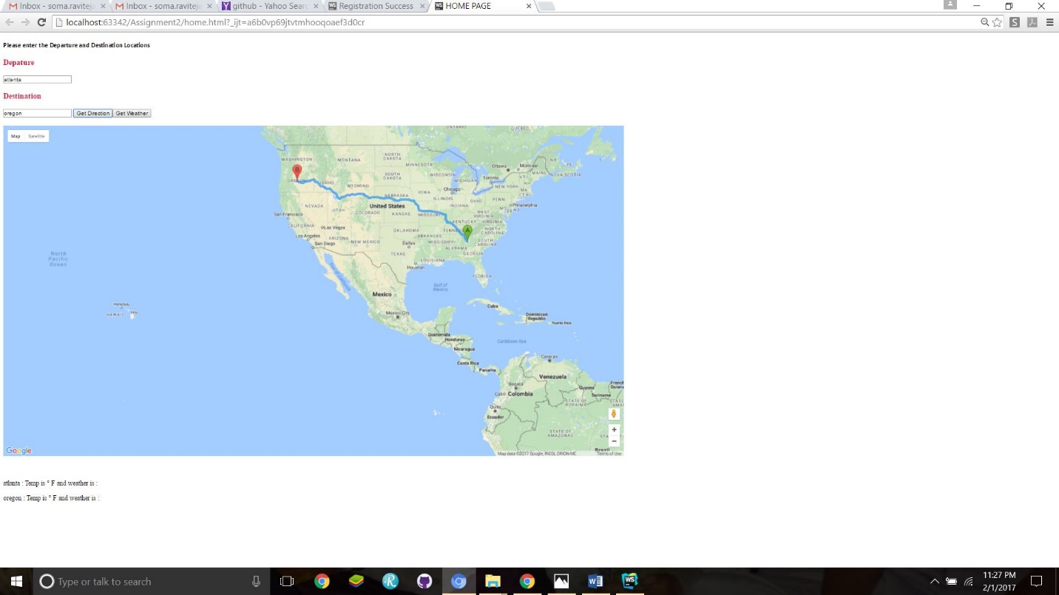

**Weather Page:**

